

**RESEARCH METHODOLOGIES AND EMERGING TECHNOLOGIES**

**(CIS013-3/CIS017-3)**

Assessment 02: Contextual Report

**Implementation of a Mobile Application that helps Users to Relieve Workplace Stress and Improve Mental Wellbeing**

BSc (Hons) Computer Science & Software Engineering

University of Bedfordshire

**Sahan Sudaraka Rathnayake**

**1916390**

# **Abstract**

Section 1 - Introduction to the project. This section will contain background details of the project, aim and objectives and description of the artefact

Section 2 - Literature Review with the market research and similar system review.

Section 3 - Project plan

Section 4 – Planning of the artefact

Contents

**Abstract** ii

**List of Figures** iv

**List of Table** v

**01. Introduction** 1

1.1Background to the project 1

1.2 Aim and Objectives 1

1.3 Description of the artefact 2

**02. Literature Review** 4

2.1 Introduction 4

2.2 Workplace stress 4

2.3 Factors Causing workplace stress 5

2.4 Impact of workplace stress 8

2.5 Market Research on workplace stress 9

2.6 Similar system review 15

2.7 Conclusion 17

**03. Project Plan** 18

3.1 Introduction 18

3.2 Gantt Chart 19

**04. Planning the Artefact** 20

4.1 Project Planning 20

4.2 Design and development 20

4.3 Testing 20

# **List of Figures**

Figure 1: Illustration of work-related stress factors and outcomes. 7

Figure 2 Pie chart of survey question one 9

Figure 3 Pie chart of survey question two 10

Figure 4 Pie chart of survey question three 11

Figure 5 Pie chart of survey question four 11

Figure 6 Bar chart of survey question five 12

Figure 7 Pie chart of survey question six 12

Figure 8 Pie chart of survey question seven 13

Figure 9 Pie chart of survey question eight 13

Figure 10 Pie chart of survey question nine 14

Figure 11 Pie chart of survey question ten 14

Figure 12 Pie chart for the survey question eleven 15

Figure 13 Frequency table for the survey question eleven 15

Figure 14 Gantt Chart 19

# **List of Table**

Table 1 Frequency table for the survey question one 9

Table 2 Frequency table for the survey question two 10

Table 3 Frequency table for the survey question three 10

Table 4 Frequency table for the survey question four 11

Table 5 Frequency table for the survey question six 12

Table 6 Frequency table for the survey question seven 12

Table 7 Frequency table for the survey question eight 13

Table 8 Frequency table for the survey question nine 13

Table 9 Frequency table for the survey question ten 14

**01. Introduction**

## **Background to the project**

Proposed system is an artificially intelligent smart mobile application that helps users to relieve workplace stress and improve mental wellbeing. This application is mainly targeted to employees who work stressfully and in need of ways to help reduce the stress and take control of the mental wellbeing. So, this is basically a digital workplace wellbeing program which will be focusing on mental health.

Workplace stress is the modern health hazard which affects the work-life balance of employees and badly affects the organization. Stress has a direct relationship between an employee and the environment they work in. And stress is built up when the demands exceed the abilities of individuals causing threats to their comfort and convenience (Beheshti and Hajizadeh, 2013). According to Health and Safety Executive (2004) job stress can cause severe mental disorders, anxiety, depression. Therefore, it’s crucial to introduce solution in reducing workplace stress.

Upon implementing the proposed system, this will provide a better and effective solution to one of the biggest medical challenge, mental illness which is caused by workplace stress. This application will be really helpful for the individuals who are suffering from work stress and need assistance. Through science and technology users will be empowered to take control of their physical and mental wellbeing which will eventually bring positive state of mind plus body.

## **1.2 Aim and Objectives**

**Aim**

* To develop a mobile application with Artificial Intelligence techniques for relieving workplace stress of employees.

**Objectives**

* To identify and evaluate existing stress relieving techniques and to identify Artificial Intelligence techniques suitable for relieving workplace stress
* To develop a system to monitor user behavioral patterns.
* To develop a personalized dashboard to display well-being score of the user.
* To develop an Artificially Intelligent system to suggest personalized stress relieving activities based on past user experience.
* To develop a chatbot as an application guide to the user.
* To evaluate the developed Artificially Intelligent application and test it on a selected group of users.

## **1.3 Description of the artefact**

The proposed system is an AI powered mobile application helps users to understand the sources of stress and teaches the users to cope with it and control it. Unique insights to the user’s mental wellbeing are provided by the application by tracking psychometric and behavioral data of the user. Application continuously monitor health data to provide the user with a wellbeing score, in real-time.

Mood data of the user will be tracked by the application which is used to analyze stress level of the user. Sleeping and eating behavioral patterns will also be tracked since these factors also affect the stress conditions of the user. Dashboard is used to display all the analyzed stress data of the user. And the improvements in stress relieving can also be accessed in the dashboard. All the stress relieving activities will be suggested through artificial intelligence. Hence the suggesting patterns will be unique to the user. A chatbot will also be designed to the system which is used to get to know about the user quickly. Since the implementation of a chatbot, user experience will be pleasant and entertaining.

Features of the system,

* Mood Analyzer

Everyday mood of the user will be tracked with the use of set of emojis.

* Sleep and Eating patterns tracking system

Sleeping patterns and eating patterns of the user will be tracked and displayed.

* Personalized Dashboard

A real-time wellbeing score will be displayed in the dashboard and stress level comparisons over the days of the week, locations, activities will also be displayed in the dashboard. Users progress in controlling stress will also be displayed in the dashboard.

* AI powered stress relieving activities suggesting system

Application uses artificial intelligence to suggest stress relieving activities based on the past data of the user. System learns about the user day by day and activities suggested will be unique to the user.

* Chatbot

A chatbot will be integrated to the system to guide the users in handling the application.

**02. Literature Review**

A proper literature review linked to workplace stress, the impact of it on the society and to individuals and the solutions given so far will be provided in this section. The importance and the reasons for the researcher to undertake the research will be highlighted in this section.

## **2.1 Introduction**

All the areas required for the research of workplace stress are covered in this literature review. Workplace stress, factors affecting workplace stress, Impact of the workplace stress on the society and solutions for it is discussed under the literature review. Market research was carried out in the aid of pointing out the importance of this research. The latter part of this literature review concentrates on the similar systems which are critically evaluated.

Keywords: Workplace Stress, Artificial Intelligence, Employees, Stressors

## **2.2 Workplace stress**

The force applied on an object to result in damage, breaking or bending is a simple definition given to the term stress in physical science. Any unfavorable or favorable demands placed upon human beings can cause the human body to respond to them which is the stress of human beings. An individual will be put in a stressful condition when the requirements of a situation or the pressure caused by the particular situation is too wide for them to handle. Prolong continuation of these stressful conditions can cause physical, mental and behavioral damages (Mansoor et al., 2011). Diverse organizational and behavioral studies confirm that workplace stress has become a universal phenomenon which is raising unpropitious health conditions. Colligan and Higgins (2006) claim that without a proper understanding of stress, as the “parent construct” workplace stress can be a very complicated scientific construct. Mcgrath (1976) defines stress as environmental instances where an individual is expected to accomplish tasks with limited resources provided that are beyond the skill level of the individual. He further states that in doing so that particular individual expects a big reward for the task.

In the present world occupation is one of the most significant sources of stress (Eremsoy, Çelimli and Gençöz, 2005). In the perspective of Peter and Siegrist (2000) incompatibility between the demands at work and the abilities of the employee can trigger work stress. Works stress obtained significant attention in psychological studies. It was renounced as one of the plagues of the 20th century by the United Nations in 1992, and later WHO introduced it as a widespread global issue (Tangri, 2003).

## **2.3 Factors Causing workplace stress**

The occupational life of each and every employee can be affected by various stressors, factors causing stress which impact on their work-life balance exerting a severe amount of psychological pressure on their mind. Studies have indicated that occupational-related factors can influence on physical, mental and behavioral health. Beheshti and Hajizadeh (2013) state that certain work-related advancements like changes in salary incomes, organizational structure improvements, new recruitments and layoffs can endanger individuals to the pressures of all sorts leaving them depressed, confused and stressed out. Further, they point out that intense amount of work, time pressures, skill imbalance can terribly damage the mental health of an employee. Work stress is due to different aspects of an organization, over time, lack of support from the organization, high demands with a lot of pressure, lack of help provided by colleagues and supervisors (Mansoor et al., 2011).

Stressors act as agents which initiate various stress reactions. Some work-related mental stressors are pleasant while some are not pleasant. For example, a job promotion can be really stressful just like a layoff. According to the thebmj (1996) website stressors can build up which is why they often found to be additive. A single stressor can trigger a chain of other stressors if remedies are not utilized. Thebmj (1996) point out the following factors to be the leading stressors causing workplace stress.

* Workload
* Poor posture
* Monotonous tasks
* Night shifts
* Overtime
* Fear about sanctions
* Happiness about promotion
* Anger due to injustice
* Challenge for a new position
* Competition with colleagues
* Conflicts with colleagues or managers
* Negative thoughts about work self
* Time pressure and deadlines

The figure mentioned below is an illustration of work-related stress factors and outcomes modelled by Michie (2002). Different types of stressors are grouped into main categories as represented below. First types are the factors that are native to the job role. Work overload is a very common stressor among all the factors. Deadlines and time pressures are also related to the job role and can vary according to the job role. Poor working conditions and lack of job control also comes with the job role. Over promotion, under promotion, not getting job security and layoffs can arise with the development of the career. Role stress, role uncertainty, conflicts within the roles are also considered as stressors which are the roles within the organization. Workplace relationships also a leading factor in a stressful working environment. Not having a good leadership, bullying, discriminations due to various reasons lead to unhealthy work relationships. Constant changes in the organizational structure also affect the workplace stress. Decision making, participation, management style variations are leading factors among these. Ultimately all of these factors lead to physical and mental health issues, burnouts, high turnovers, job strain and poor performance among individuals of the organization. This is going to affect badly to the employee and to the organization itself.



Figure 1: Illustration of work-related stress factors and outcomes.

Source: (Michie, 2002)

## **2.4 Impact of workplace stress**

The three physical, mental, and social dimensions are all together can be stated as health which is a multidimensional concept. Human health can be jeopardized due to stress, causing to collapse in physical and mental status. Getting exposed to work-related stresses for long periods of time can result in burnouts (Beheshti and Hajizadeh, 2013). Kawakami and Haratani (1999) state that repeated and the long-term severe stress levels can impact negatively on employees’ physical and mental health. According to the Health and Safety Executive (2004) approximately half a million people in the United Kingdom are suffering from ill conditions due to work-related stress conditions. And furthermore, around 5 million feel “severe” or “extreme” levels of workplace stress and the society spends around £3.7 billion every year due to stress conditions (Yadegarfar et al.,2010). The stress studies carried out in Iran showed the existence of high levels of workplace stress to be about 14.4% (Embriaco et al., 2007). Mathee et al. (2010) concluded that about 70% of employees observed at their occupations had indications of stress or tension which was estimated by the American Academy of Family Physicians. Moreover, it is stated that 30% of employed society affected by the work stress in developed countries, where these numbers increase drastically in developing countries (Mathee et al., 2010). Tangri (2013) states that the depth of the job stress situation is well acknowledged for an instance in the United Kingdom about 13.5 million work operation days were wasted due to depression, anxiety and job stress in 2007/2008. Going further, 3.5% of the Gross Domestic Product (GDP) of each country were utilized for job stress-related problems according to the International Labor Organization (ILO) (Beheshti and Hajizadeh, 2013). These shocking numbers explain how much of a plague that workplace stress has become to the world and individuals.

According to Beer and Newman (1978), mild mental disorders prevail in individuals suffering from high levels of work stress. Further, they state addiction to drugs, neglecting work, reduced motivation is common among stressed people. In extreme levels of work stress employees tend to pay disinterest in work or frequent absenteeism or quitting their job completely (Johnson et al., 2005). Common health hazards like smoking, skipping meals, alcohol consumption, excessive caffeine addiction can be identified in stressed-out employees. So, it very much clear that workplace stress impact severely on society.

## **2.5 Market Research on workplace stress**

A market research was conducted by the researcher to further study on the importance of proposed research and the situation of workplace stress in the current society. A survey of selected questionnaire was passed on to 780 employees of different industries to gather the data. Then the gathered data was analyzed using IBM SPSS Statics software.

For the survey to be more accurate, individuals were selected from different industrial fields. As shown in the below figures several industrial fields were chosen.

What industry do you work in? *

* IT industry
* Health and medical care
* Education / Academia
* Engineering
* Technical
* Service
* Other:

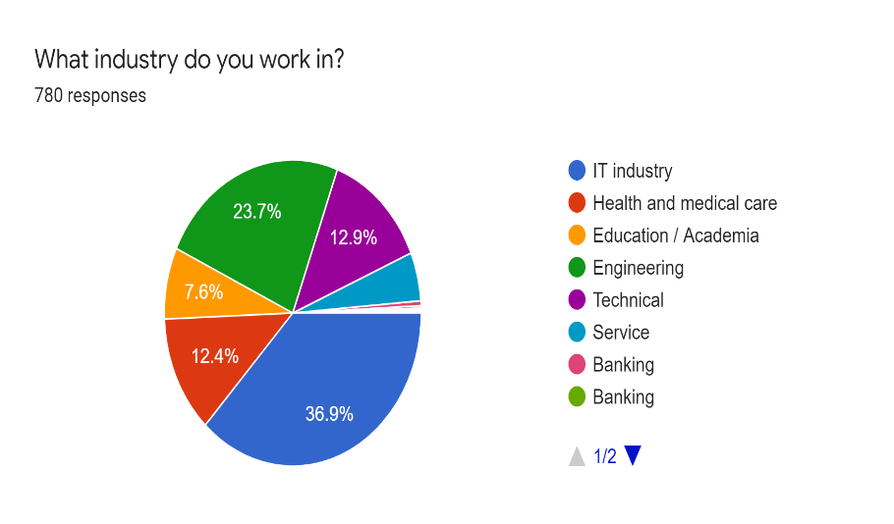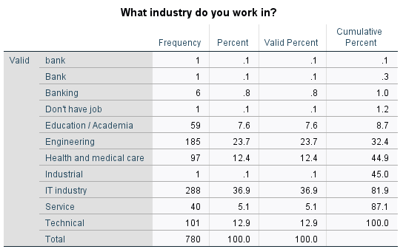

Figure Pie chart of survey question one

Table Frequency table for the survey question one

Job satisfaction is negatively affected by work stress (Yahaya et al., 2010). So, the survey was used to analyze how much of a satisfaction employees have towards their jobs. More than 70% of the selected employees didn’t seem to like what they perform at their work.

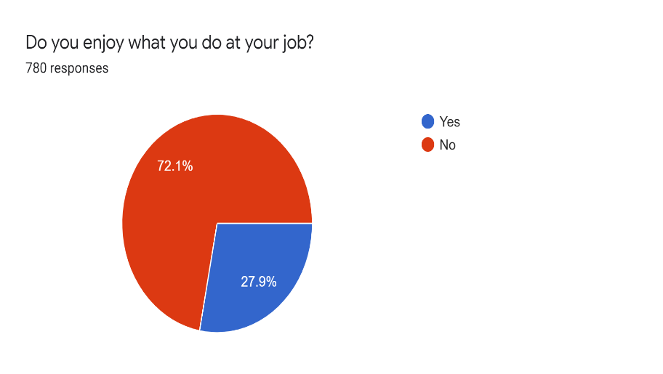

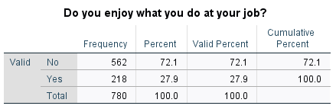

Table Frequency table for the survey question two

Figure Pie chart of survey question two

Next the survey was focused on how the employees feel about their stress levels. Among the 780 individuals more than 80% are feeling stressed at work 54% of these stress levels are severe.

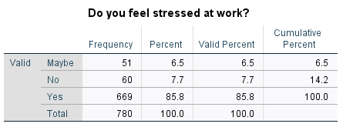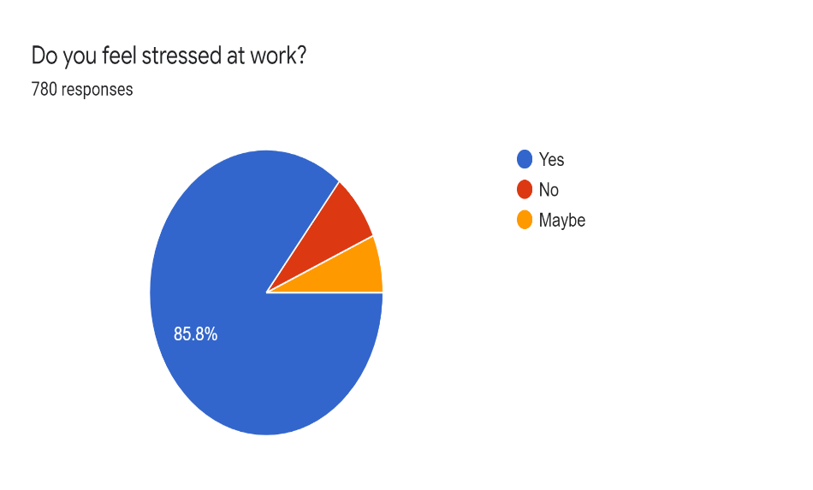

Table Frequency table for the survey question three

Figure Pie chart of survey question three

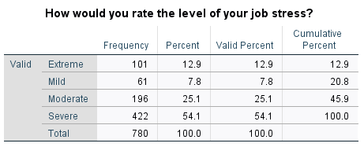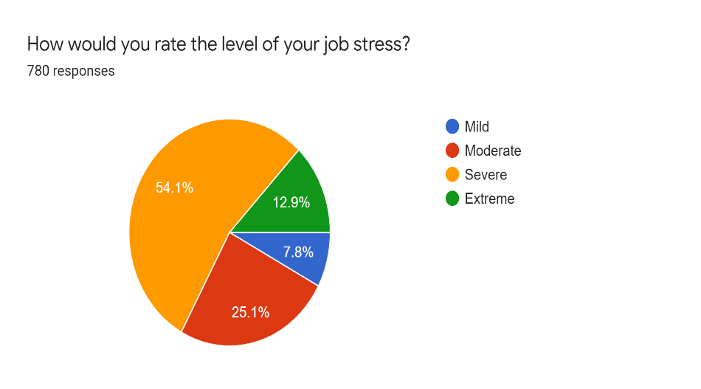

Table Frequency table for the survey question four

Figure Pie chart of survey question four

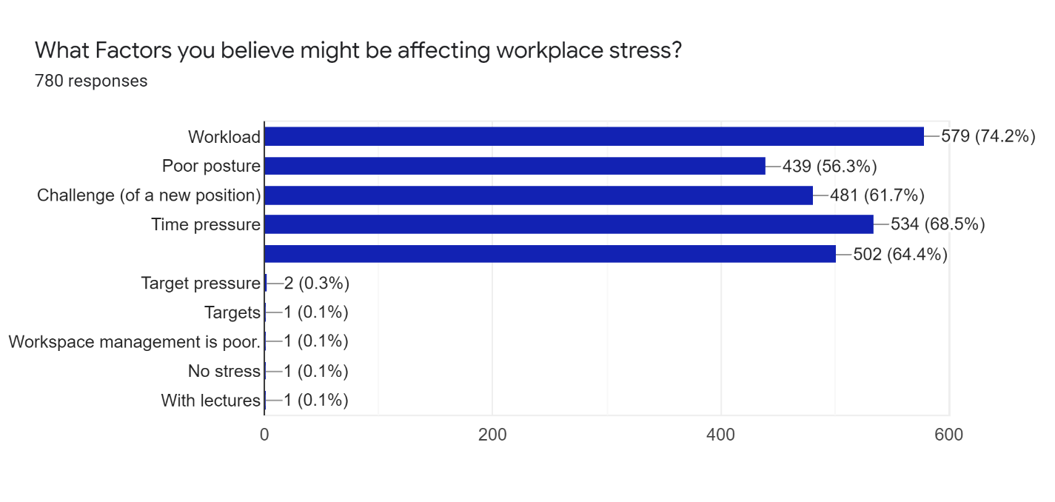Among the factors affecting work stress following factors seemed to be common according to the employee point of view. Workload and time pressures affect most of the employees as shown in the below figure.

When the employees are always demanded to perform well in their profession the stress levels rise. Below figures illustrates that about 80% is always expected to perform well at work.

Figure Bar chart of survey question five

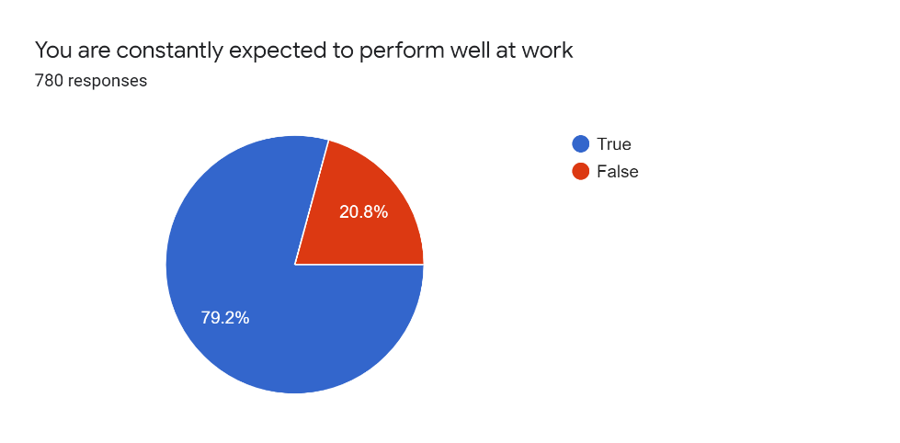

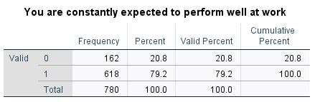

Figure Pie chart of survey question six

Table Frequency table for the survey question six

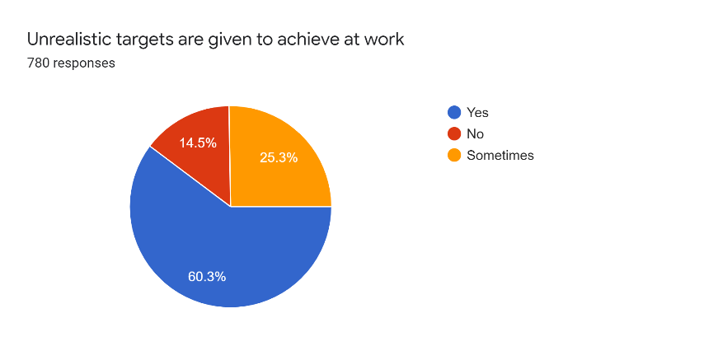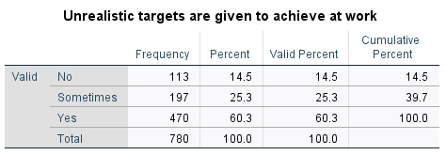Workload pressure on an individual increase drastically when targets are provided which are impossible to achieve on time and when the employee has no control over the assigned work. Out of 780 employees majority agreed to be had no control over the assigned work and workload is too much on them.

Table Frequency table for the survey question seven

Figure Pie chart of survey question seven

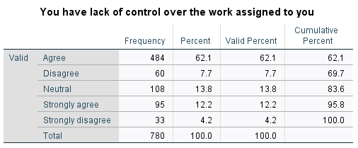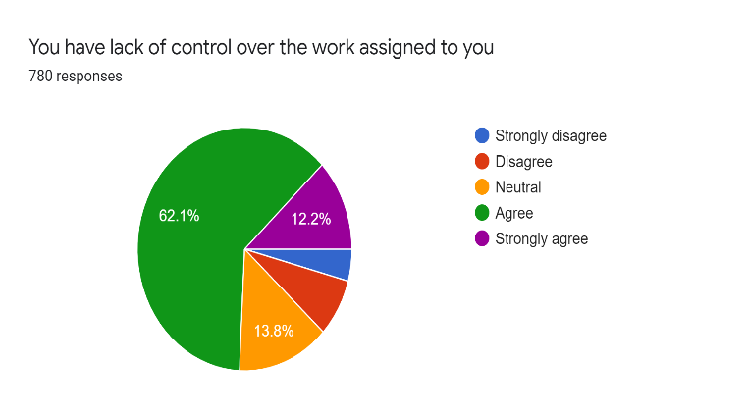

Table Frequency table for the survey question eight

Figure Pie chart of survey question eight

Studies have confirmed that constant work postures can affect badly in physical health of employees which ultimately leads to mental stress conditions. According to the results pf figures attached below most of employees, above 70% are working in a constant posture.

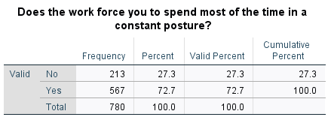

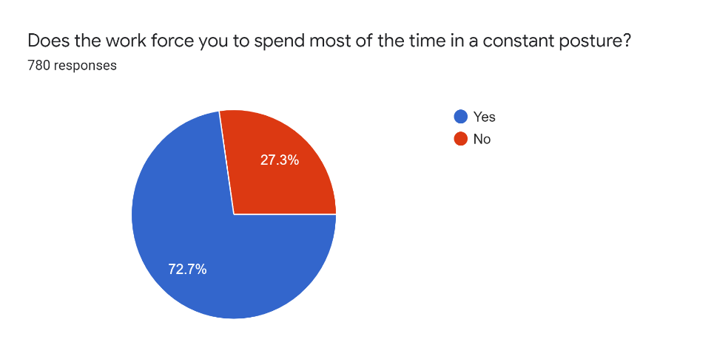

Table Frequency table for the survey question nine

Figure Pie chart of survey question nine

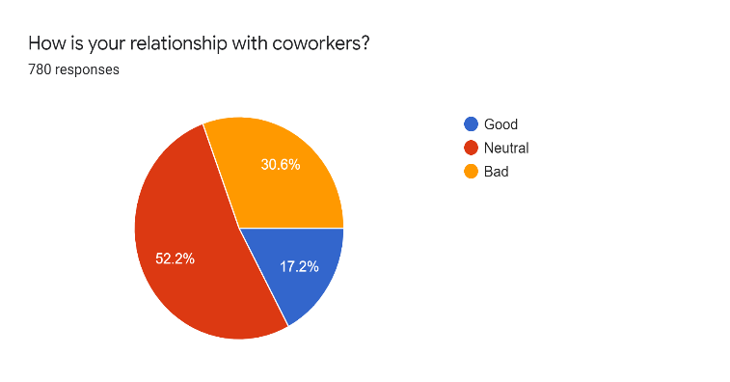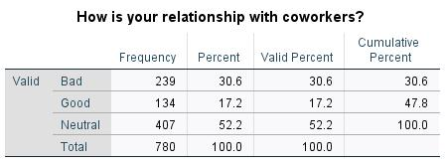Relationships maintained at the workplace also determine stress levels of employees. According to the survey half of individuals happened to have a neutral relationship with coworkers and sometimes they tend to have arguments with supervisors and coworkers.

Table Frequency table for the survey question ten

Figure Pie chart of survey question ten

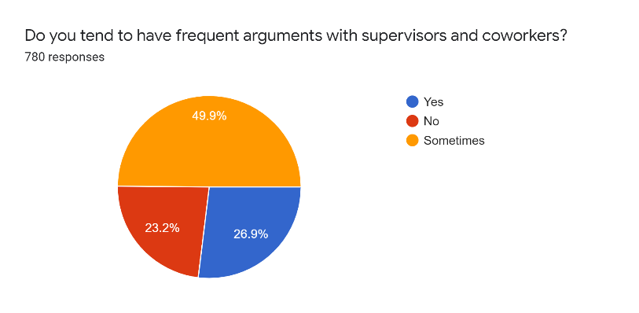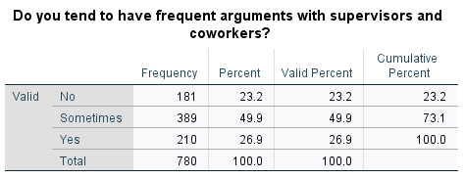

Figure Pie chart for the survey question eleven

Figure Frequency table for the survey question eleven

## **2.6 Similar system review**

**2.6.1 Oiva**

Oiva is a mobile application designed to train mental wellness. The application was targeted for working-age individuals. This mobile application was designed based on acceptance and commitment therapy (ACT). This application uses several stress relieving activities like mindful sitting, mindful breathing, mindful listening. When an individual is feeling stressed that stress can be reduced by following the activities that are generally displayed in the application.

This application takes the users generally and suggest the stress relieving activities. So, the user must decide which activity is the best solution for stress.

**2.6.2 Happier Healers**

Medical students proven to have higher rates of depression, anxiety or stress than the general population. Meditation programs are often used as remedy for stress related situations and proven to have high accuracy rates than any other programs. So, this mobile application is basically an audio-guided mindfulness meditation program. This application guides the users to follow a meditation program whenever they feel stressed-out. Users can access the program through an audio guided feature.

Although meditation is a very effective stress relieving activity it might not suit some users. So, the application is limited to a meditation program and doesn’t give a common solution to all of the stressed-out individuals.

**2.6.3 Relax lite: Stress Relief**

This is a rapid stress relief mobile application. This application is designed with guided breathing and meditation exercises which promote relaxation by the calming music used in the background. This is a very simple mobile application. This mobile application contains following features.

* A structured breathing courses
* Eight-minute guided meditation session
* Quick start

This application also limits to a breathing activity and a meditation program. Some users might not response to these activities.

**2.6.4 Anti Stress – Anxiety Relief Relaxing Games**

This mobile application is a collection of different relaxing games. It allows users to complete challenges and get rid of the day to day stress. So, this is an entertaining application which is managing stress through fun related activities. Some games that can be seen are,

* Card games
* Piano games
* Fidget spinner games
* Knife hit games

The game features that can be seen are,

* Brain exercise and relaxation
* Mind freshness activities
* Relaxing sounds
* Smooth controls

This also a good approach to reduce stress but still it is limited to gaming activities. Therefore, it doesn’t provide a common solution to stress situation of users.

**2.6.5 Stress Management – Effectively Reduce Stress**

This application contains a e book about ways of effectively reducing stress. Basically, users need to go through chapters and understand the stress levels by diagnosing their symptoms. Then the factors causing the stress and different ways of reducing stress. This e book will contain tips and tricks on how to cope with stress and how to deal with it. This application contains,

* Methods of responding to stress
* Steps in stress management
* Ways of reducing stress

So, this is application requires a lot of users’ time to read and understand the e book. And time is very crucial for an employee leading a busy lifestyle with tight schedules. And even after reading the e book knowledge gained can vary from user to user which can cause in the effectiveness of the application. That is drawback identified in this application.

## 

## **2.7 Conclusion**

Since workplace stress is a very common health hazard in present society, various solutions are introduced to control it. Mobile application is given as a solution also can be seen among these. In reviewing the mobile application introduced so far it is clear that those applications are very immature and simple in functioning. These mobile applications contain various limitations and drawbacks. Set of stress-relieving activities just included in an application is the most common scenario. These activities can contain a breathing exercise, meditation program, listening activities. Another common scenario is the anti-stress games. All these grant solutions in general which is not an effective way since mental health is a very personalized matter and the situations can vary from user to user.

As discussed, giving a general solution is not the most effective way of reaching the stressed-out employees. With a dumb application, this challenge can never be achieved. Therefore, what it needs is a smart mobile application which can take decisions of its own according to the needs and requirements of the user. This can only be catered by introducing a mobile application powered by artificial intelligence (AI). Using AI, the application will decide which anti-stress activity is effective to which user. And user’s behavioral patterns play a major role in stress-related situations. If these behavioral patterns are not tracked, it is impossible to analyze the stress level of users. If the application is going to be successful, the user is going to need a place in the mobile application to view their stress levels and their improvements in stress conditions. With the development of a chatbot, users pay a more tendency to interact with the application daily.

Since all these mentioned features are going to be integrated into the proposed system, it will be a more effective and efficient application. Since workplace stress is one of the main threats to society and the proposed system will bring positive results in reducing the said threat it is very crucial that such a system is developed and released among the stressed-out employees.

**03. Project Plan**

## **3.1 Introduction**

Main task of the proposed project is to develop a stress relieving mobile application. Agile methodology is used for the implementation of the proposed system. Development phase is divided into several sprints. Functions of the system will be separately implemented in these sprints. After every sprint, sprint tests will be carried out.

## **3.2 Gantt Chart**



Figure 14 Gantt Chart

Up to contextual report submission is done now. Next milestone is to finalize system functions and begin with the system implementation while testing the system parallelly.

**04. Planning the Artefact**

## **4.1 Project Planning**

The proposed system was planned to be developed as a solution for workplace stress. Requirements were gathered by literature review and the market research.

## **4.2 Design and development**

Tools used will be,

* Android studio
* Java
* Appium

## **4.3 Testing**

Unit testing, smoke testing and regression testing will be carried out to test the application. Further sprint wise testing will also be performed.

**05. References**

1. Colligan, T. and Higgins, E. (2006). Workplace Stress. Journal of Workplace Behavioral Health, 21(2), pp.89-97.
2. Beheshti, M. and Hajizadeh, R. (2013). Workload, occupational stress, and general health of female employees of public welfare centers. Journal of Occupational Health and Epidemiology, 2(4), pp.174-182.
3. Eremsoy, C., Çelimli, Ş. and Gençöz, T. (2005). Students under academic stress in a Turkish University: Variables associated with symptoms of depression and anxiety. Current Psychology, 24(2), pp.123-133.
4. Peter, R. and Siegrist, J. (2000). Psychosocial work environment and the risk of coronary heart disease. International Archives of Occupational and Environmental Health, 73(S1), pp.S41-S45.
5. KAWAKAMI, N. and HARATANI, T. (1999). Epidemiology of Job Stress and Health in Japan: Review of Current Evidence and Future Direction. INDUSTRIAL HEALTH, 37(2), pp.174-186.
6. Tangri R. Stress costs, Stress-cures. Britain:Trafford Publishing; 2003
7. Yadegarfar G, Alinia T, Gharaaghaji R, Allahyari T, Sheikhbagloo R. Study of Association between Job Stress and Cardiovascular Disease Risk Factors among Urmia Petrochemical Company Personell. Journal of Isfahan Medical School 2010; 28(112):645-60
8. Embriaco, N., Papazian, L., Kentish-Barnes, N., Pochard, F. and Azoulay, E. (2007). Burnout syndrome among critical care healthcare workers. Current Opinion in Critical Care, 13(5), pp.482-488.
9. Mathee, A., Oba, J. and Rose, A. (2010). Climate change impacts on working people (the HOTHAPS initiative): findings of the South African pilot study. Global Health Action, 3(1), p.5612.
10. Mansoor, M., Fida, S., Nasir, S. and Ahmad, Z. (2011). The Impact of Job Stress on Employee Job Satisfaction A Study on Telecommunication Sector of Pakistan. 2(3).
11. Mcgrath, J. (1976). Stress and behavior in organizations. In M.D. Dunnette (Ed), 1976 Handbook of Industrial and Organizational Psychology. Palo Alto, CA. Counseling psychological stress.
12. BEEHR, T. and NEWMAN, J. (1978). JOB STRESS, EMPLOYEE HEALTH, AND ORGANIZATIONAL EFFECTIVENESS: A FACET ANALYSIS, MODEL, AND LITERATURE REVIEW. Personnel Psychology, 31(4), pp.665-699.
13. thebmj. (1996). [online] Available at: https://www.bmj.com/content/313/7059/745.full [Accessed 4 Jan. 2020].
14. Mann, S. (2002). Organizational Stress: A Review and Critique of Theory, Research and Applications20024Cary L Cooper, Philip J Dewe and Michael P. O’Driscoll. Organizational Stress: A Review and Critique of Theory, Research and Applications. Sage Publications, 2001. 288 pages, ISBN: ISBN 0‐7619‐1480‐3 £47.00 (cloth), ISBN: ISBN 0‐7619‐1481‐1 £18.99 (paper). Leadership & Organization Development Journal, 23(5), pp.295-296.
15. Health and Safety Executive. (2004). Stress at work - HSE. [online] Available at: https://www.hse.gov.uk/stress/index.htm [Accessed 2 Jan. 2020].
16. Johnson, S., Cooper, C., Cartwright, S., Donald, I., Taylor, P. and Millet, C. (2005). The experience of work‐related stress across occupations. Journal of Managerial Psychology, 20(2), pp.178-187.
17. Yahaya, N., Yahaya, A., Tamyes, F., Ismail, J. and Jaalam, S. (2010). The Effect of Various Modes of Occupational Stress, Job Satisfaction, Intention to Leave and Absentism Companies Commission of Malaysia. Australian Journal of Basic and Applied Science.
18. Babatunde, A. (2013). Occupational Stress: A Review on Conceptualisations, Causes and Cure, 2(3).